Danube Transnational Programme
Information Day
8 October 2015
Venue:
District Administration Pleven, hall “Pleven”
Pleven, Bulgaria

Preliminary Agenda
9:00 - 9:30 | Registration /Welcome drink
9:30 – 09:40 | Welcome and introduction  by Deputy Minister of Regional Development and Public Works  by District Governor of the District of Pleven
9:40 – 11:00 | Introduction of DANUBE Programme  Presentation of the Programme: (representative of DANUBE Programme Joint Secretariat tbc):  - understanding new features of programme - history and evolution, eligible area, priorities, procedures and key documents;  - regional dimension of the cooperation (synergies with other transnational programmes in the area and links with the EU Strategy for the Danube Region (EUSDR);  - nature/ role of project partners;  - opportunities of cooperation in the Danube Transnational Programme, types and examples of cooperation.  Questions and Answers
11:00 – 11:20 | Coffee Break
11:20 -12:30 | Support for projects  First call for proposals -– main elements, rules and procedures  - call timing,  - Danube TP application manual - Project generation;  - application process - technical requirements and expectations;  - Expression of Interest (EoI) - How to fill in the EoI, lessons to be learned;  - applicant supporting tools and bodies, (representative of DTP Joint Secretariat, tbc)  Questions and Answers
12:30 -13:00 | National co-financing, national system for First Level Control, partner search assistance  (DTP National Contact Point - representative of “Territorial Cooperation Management” DG, tbc)  Questions and Answers
13:00 – 14:00 | Lunch
14:00- 16:00 | Types and examples of cooperation  Inspiration for project ideas & Project idea generation  Achievements of BG project partners in SEE transnational cooperation programme - group discussions with BG project partners around 3 tables within 3 themes related to the new DTP priorities.  #1 on SEE Facilitation of innovation and entrepreneurship  related to DTP Innovative and socially responsible Danube region  #2 SEE Protection and improvement of the environment & Development of transnational synergies for sustainable growth areas  related to DTP Environment and culture responsible Danube region  #3 SEE Improvement of the accessibility  related to DTP Better connected and energy responsible Danube region
16:00 | Wrap-up & End of the day  Evaluation form

How to register
Please, register for the event by filling in the online registration form available at the following link http://goo.gl/forms/ZCOZJfrkw1 as soon as possible, the latest by 2nd October 2015.
Venue: District Administration Pleven, hall “Pleven”, Pleven, 1 Vazrazdane square 1
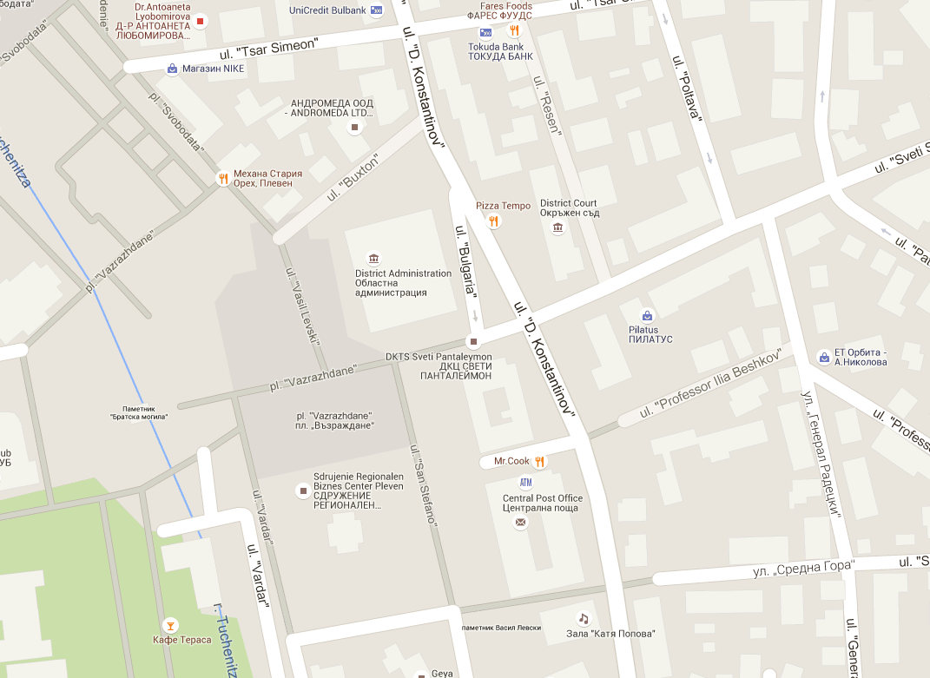

Travel and accommodation arrangements:

Participants are kindly asked to make their own travel and accommodation arrangements.

How to get to the District Administration Pleven:
On foot: 20 minutes from the Central Railway /Bus Station, http://avtogara.pleven.bg/index.php

By public transport: Trolleybus 5, 6, 9. Trip time: 8-9 min. (4 min. by transport + 3 - 4 min. on foot) from the Central Railway /Bus Station, http://bg.easyway.info/en/cities/pleven

