Danube Transnational Programme
Information Day
2nd Call for proposals

9 March 2017
Venue: Best Western Hotel Expo
149 Tsarigradsko Shose, Blvd.,Sofia
Preliminary Agenda
Time | Topic
9:00 - 09:30 | REGISTRATION
9:30 – 09:45 | WELCOME AND INTRODUCTION  by representatives of Ministry of Regional Development and Public Works, “Territorial Cooperation Management” DG,
9:45 – 10:00 | DTP – MY STORY (representative of DANUBE Programme Joint Secretariat)  - What is my mission?  - Who is managing me?  - What activities am I financing?  - What costs am I reimbursing?  - Who can apply?  - What type of funds do I have in the programme?
10:00 – 11:00 | MY SECOND CALL (representative of DANUBE Programme Joint Secretariat)  - When is it going to be launched?  - Which of my SOs can be addressed? Is there a thematic restriction?  - How long can a project be?  - How much money do I have?  Questions and Answers
11:00 – 11:30 | Coffee break
11:30 – 13:00 | HOW TO DEVELOP A SUCCESFULL PROJECT? (representative of DANUBE Programme Joint Secretariat)  - Start with the project idea…  - Look for the ideal partnership…  - Develop the intervention logic…  - Develop the workplan…  - Create synergies and capitalise…  Questions and Answers
13:00 –13:30 | Coffee break
13:30- 13:45 | Successful project in the 1st Call - Presentation of LENA project (representative of LENA project)
13:45 – 14:15 | HOW IS JS ASSESSING PROJECTS? (representative of DANUBE Programme Joint Secretariat)  - What is the procedure?  - Eligibility assessment…  - Quality assessment…
14:15-14:30 | AND IF YOU ARE SUCCESFULL(representative of DANUBE Programme Joint Secretariat)  - You have to ensure the quality of your outputs…  - You have to report…
14:30- 15:00 | ARE THERE ANY NATIONAL RULES? (DTP National Contact Point - representative of “Territorial Cooperation Management” DG, tbc)  - Eligibility of Bulgarian partners  - National co-financing,  - National system of First Level Control,  - Common mistakes and lessons learned from 1st CfPs  Questions and Answers
15:00 | Wrap up & End of the day  Evaluation form
15:30 – 17:00 | Individual consultations (by appointment – 30 min/ project)  DTP applicants have the possibility to individually consult with the Joint Secretariat on their project ideas after the Information Day.  Project ideas being at an early stage of development are recommended to first address the National Contact Point for general advice and information. A consultation with the Joint Secretariat could comprise all main aspects of the application preparation (partnership, content, work plan).  It could only be requested by email by 28 February 2017 including a written project outline based on a pre-defined DTP Concept Note (available at http://www.interreg-danube.eu/media/download/32).  Additionally, applicants are requested to highlight the main questions to be answered by the Joint Secretariat. The requests for project consultation not based on the official DTP Concept Note template will not be considered.  For requesting an individual consultation, applicants have to contact the JS Project Officer Niculae Marius Valentin (niculae.marius-valentin@ngm.gov.hu). Bilateral on-site consultations are limited to 30 minutes
How to register
Please, register for the event by filling in the online registration form available at the following link https://goo.gl/forms/KeoGW839xHqlARJ03 as soon as possible. There is a limited capacity for attendance, so only 1 participant per organization will be signed in for participation on the first come, first served principle, the latest by 6 March 2017. A formal confirmation of participation will be sent out later by e-mail.
If maximum capacity is reached, the registration will be closed prior to the deadline.

Venue: Best Western Hotel Expo, 149 Tsarigradsko Shose, Blvd.
www.hotelexposofia.com
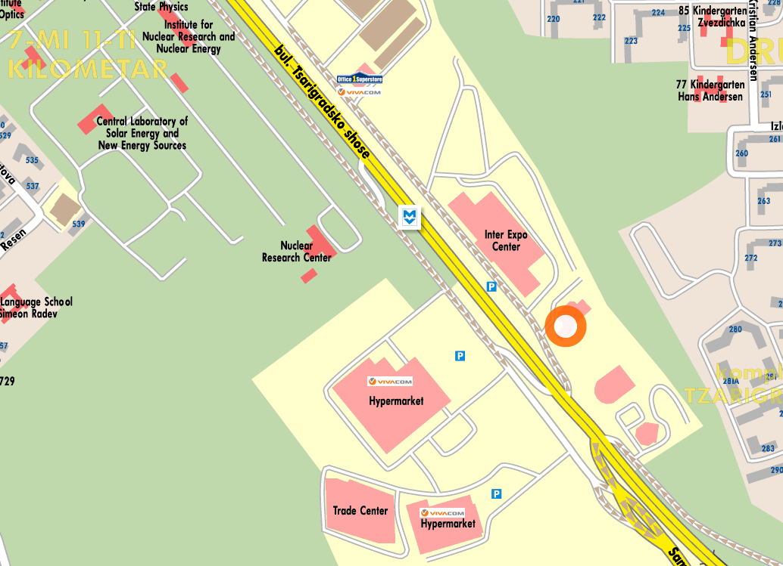
Best Western Expo Hotel Sofia is within several minutes from the majority key business points and touristic locations: visitors can reach Sofia's International Airport with direct Metro connection in only 2 minutes, and the city center within 12 minutes. “Tsarigradsko shousse” Metro Station is located outside the hotel.

